Overall experiment variables 2
1. Effect of RPM on lift force at constant wind speed for each airfoil 2
stella - r = 57.91/2000; % radius in [m] 2
Bud - r = 83.82/2000; % radius in [m] 6
Quaker - r = 128.27/2000; % radius in [m] 9
comparison to theory completed, looking for patterns within the collected 13
2. Effect of changing wind speed on lift force 15
Calculating Reynolds number for 3 cylinders and all 4 speeds 15
Plotting all the data 16
fitting the wind speed data 19
3. Effect of increasing wind speed on a fixed RPM on the lift force 21
Plotting and fitting 21
Error Analysis 21
Plotting everythang 22
Calculateing the Coefficient of Lift 23
Plot Theoretical Coefficent of Lift 24
Calculateing the Coefficient of Lift 26
Plot for Experimental Coefficient of Lift 27
Experimental vs Theoretical CL 30
Vortex Shedding 31
Misc Info 32
clear all;
close all;
clc;
% Magnus Effect Overview
% Variables:
% FL: lift force - measured by force balance
% rho: air density - calculated from the day's atmospheric pressure
% v: air speed - calculated using pitot tube
% G: vortex strength - found using G = 2*pi*r^2*omega
% r: cylinder radius
% omega: RPM in rad/s
% L: length of the cylinder
% FL = rho*v*G*L = rho*v*4*pi^2*r^2*omega*L = rho*v*4*pi^2*r^2*omega*L
%
% Topics to analyze:
% 1. Effect of changing RPM on lift force at constant wind speed
% - expect linear relationship
% 2. Effect of changing wind speed on lift force at constant RPM
% - expect linear relationship
% 3. Effect of linearly increasing wind speed on lift force
% - expect linear relationship
%%%%%%%%%%%%%%%%%%%%%%%%%%%%%%%%%%%%%%%%%%%%%%%%%%%%%%%%%%
% Authors: Feng, Zhangxi; Popecki, Simon; Skinner, James %
% Course: ME646 %
% Project: Cylindrical Airfoil Magnus Effect %
% Date: May 1, 2017 %
%%%%%%%%%%%%%%%%%%%%%%%%%%%%%%%%%%%%%%%%%%%%%%%%%%%%%%%%%%

Overall experiment variables
See attached excel sheet for the experiment data windspeeds from pitot tube readings:
speed4 = 24.01946618; % [m/s]
speed3 = 19.78614266;
speed2 = 16.36650742;
speed1 = 12.00973309;
airrho = 1.2093;
% [kg/m^3] from ideal gas law and the barometric pressure of the day

1. Effect of RPM on lift force at constant wind speed for each airfoil

stella - r = 57.91/2000; % radius in [m]
rStella = 57.91/2000;
LStella = 0.130175; % length of stella in meters
forceStella = [0.5,1.45,1.96;...
1.25,1.48,2.28;...
1.35,1.27,2.31;...
1.43,1.17,2.11];
RPMStella = [3100,4060,6000;...
3024,4130,5960;...
2950,3930,5950;...
2800,4000,5870]; % convert from [rpm] to [rps]
% expected relationship
RPMMagnusStella = (2800:100:6000); % [rpm]
% FL = 4*pi^2*r^2*rho*v*omega*L
FLStella4 = 4*pi^2*rStella^2*airrho*speed4.*RPMMagnusStella/60*LStella;
FLStella3 = 4*pi^2*rStella^2*airrho*speed3.*RPMMagnusStella/60*LStella;
FLStella2 = 4*pi^2*rStella^2*airrho*speed2.*RPMMagnusStella/60*LStella;
FLStella1 = 4*pi^2*rStella^2*airrho*speed1.*RPMMagnusStella/60*LStella;
% polyfitting data to line
% speed4
stellaFit4 = polyfit(RPMStella(4,:),forceStella(4,:),1);
stellaFit4x = 2800:(5870-2800)/1000:5870;
stellaFit4y = stellaFit4x*stellaFit4(1) + stellaFit4(2);
% speed3
stellaFit3 = polyfit(RPMStella(3,:),forceStella(3,:),1);
stellaFit3x = 2950:(5950-2950)/1000:5950;
stellaFit3y = stellaFit3x*stellaFit3(1) + stellaFit3(2);
% speed2
stellaFit2 = polyfit(RPMStella(2,:),forceStella(2,:),1);
stellaFit2x = 3024:(5960-3024)/1000:5960;
stellaFit2y = stellaFit2x*stellaFit2(1) + stellaFit2(2);
% speed1
stellaFit1 = polyfit(RPMStella(1,:),forceStella(1,:),1);
stellaFit1x = 3100:(6000-3100)/1000:6000;
stellaFit1y = stellaFit1x*stellaFit1(1) + stellaFit1(2);
% speed4 plots
figure;
hold on;
plot(RPMMagnusStella,FLStella4,'r--');
plot(RPMStella(4,:),forceStella(4,:),'bx',stellaFit4x,stellaFit4y,'b');
xlabel('Cylinder Rotation Speed [RPM]');
ylabel('Lift Force (N)');
title('Stella Cylinder Lift Force vs. RPM at 24.0 m/s');
l = legend('Magnus Predicted','Experiment Data','Experiment Fit','Location','best');
%set(l,'FontSize',12);
% speed3 plots
figure;
hold on;
plot(RPMMagnusStella,FLStella3,'r--');
plot(RPMStella(3,:),forceStella(3,:),'bx',stellaFit3x,stellaFit3y,'b');
xlabel('Cylinder Rotation Speed [RPM]');
ylabel('Lift Force (N)');
title('Stella Cylinder Lift Force vs. RPM at 19.8 m/s');
l = legend('Magnus Predicted','Experiment Data','Experiment Fit','Location','best');
set(l,'FontSize',12);
% speed2 plots
figure;
hold on;
plot(RPMMagnusStella,FLStella2,'r--');
plot(RPMStella(2,:),forceStella(2,:),'bx',stellaFit2x,stellaFit2y,'b');
xlabel('Cylinder Rotation Speed [RPM]');
ylabel('Lift Force (N)');
title('Stella Cylinder Lift Force vs. RPM at 16.4 m/s');
l = legend('Magnus Predicted','Experiment Data','Experiment Fit','Location','best');
%set(l,'FontSize',12);
% speed1 plots
figure;
hold on;
plot(RPMMagnusStella,FLStella1,'r--');
plot(RPMStella(1,:),forceStella(1,:),'bx',stellaFit1x,stellaFit1y,'b');
xlabel('Cylinder Rotation Speed [RPM]');
ylabel('Lift Force (N)');
title('Stella Cylinder Lift Force vs. RPM at 12.0 m/s');
l = legend('Magnus Predicted','Experiment Data','Experiment Fit','Location','best');
%set(l,'FontSize',12);
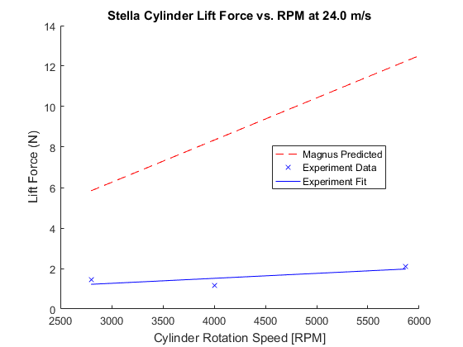
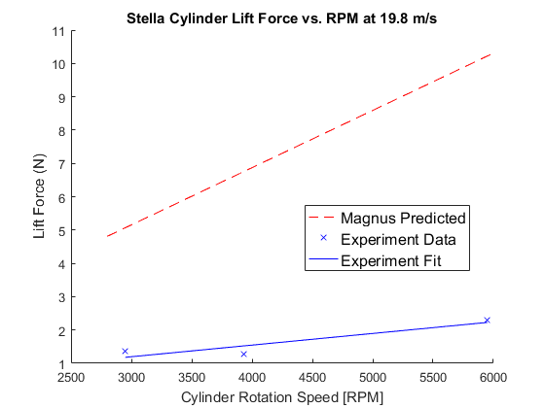
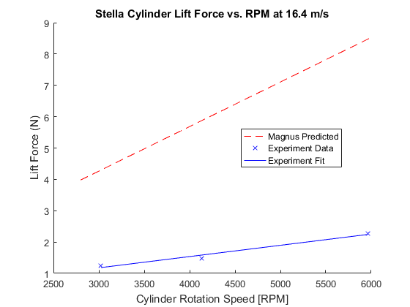
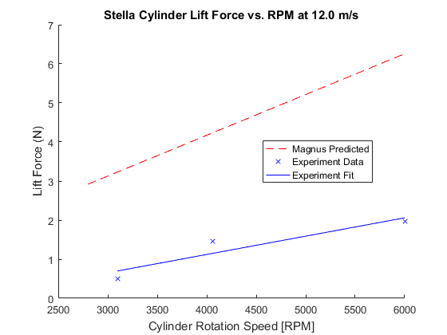

Bud - r = 83.82/2000; % radius in [m]
rBud = 83.82/2000; % finding radius from diamter in [mm] to [m]
LBud = 0.1762125; % length of bud cylinder in meters
forceBud = [2.3,3.17,1.65;...
0,0,0;...
10.13,21.92,13.91;...
10.25,13.11,8.97];
RPMBud = [3200,4940,5800;...
0,0,0;...
3291,4700,5844;...
3100,4860,5916]; % convert from [rpm] to [rps]
% expected relationship
RPMMagnusBud = (2500:100:6000); % [rpm]
% FL = 4*pi^2*r^2*rho*v*omega*L
FLBud4 = 4*pi^2*rBud^2*airrho*speed4.*RPMMagnusBud/60*LBud;
FLBud3 = 4*pi^2*rBud^2*airrho*speed3.*RPMMagnusBud/60*LBud;
FLBud2 = 4*pi^2*rBud^2*airrho*speed2.*RPMMagnusBud/60*LBud;
FLBud1 = 4*pi^2*rBud^2*airrho*speed1.*RPMMagnusBud/60*LBud;
% polyfitting data to line
% speed4
budFit4 = polyfit(RPMBud(4,:),forceBud(4,:),1);
budFit4x = 3100:(5916-3100)/1000:5916;
budFit4y = budFit4x*budFit4(1) + budFit4(2);
% speed3
budFit3 = polyfit(RPMBud(3,:),forceBud(3,:),1);
budFit3x = 3291:(5844-3291)/1000:5844;
budFit3y = budFit3x*budFit3(1) + budFit3(2);
% speed1
budFit1 = polyfit(RPMBud(1,:),forceBud(1,:),1);
budFit1x = 3200:(5800-3200)/1000:5800;
budFit1y = budFit1x*budFit1(1) + budFit1(2);
% speed4 plots
figure;
hold on;
plot(RPMMagnusBud,FLBud4,'r--');
plot(RPMBud(4,:),forceBud(4,:),'bx',budFit4x,budFit4y,'b');
xlabel('Cylinder Rotation Speed [RPM]');
ylabel('Lift Force (N)');
title('Bud Heavy Cylinder Lift Force vs. RPM at 24.0 m/s');
l = legend('Magnus Predicted','Experiment Data','Experiment Fit','Location','best');
%set(l,'FontSize',12);
% speed3 plots
figure;
hold on;
plot(RPMMagnusBud,FLBud3,'r--');
plot(RPMBud(3,:),forceBud(3,:),'bx',budFit3x,budFit3y,'b');
xlabel('Cylinder Rotation Speed [RPM]');
ylabel('Lift Force (N)');
title('Bud Heavy Lift Force vs. RPM at 19.8 m/s');
l = legend('Magnus Predicted','Experiment Data','Experiment Fit','Location','best');
%set(l,'FontSize',12);
% speed2 plot for Bud does not exist
% speed1 plots
figure;
hold on;
plot(RPMMagnusBud,FLBud1,'r--');
plot(RPMBud(1,:),forceBud(1,:),'bx',budFit1x,budFit1y,'b');
xlabel('Cylinder Rotation Speed [RPM]');
ylabel('Lift Force (N)');
title('Bud Heavy Cylinder Lift Force vs. RPM at 12.0 m/s');
l = legend('Magnus Predicted','Experiment Data','Experiment Fit','Location','best');
%set(l,'FontSize',12);
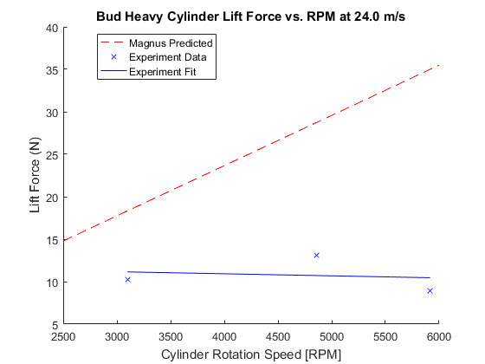
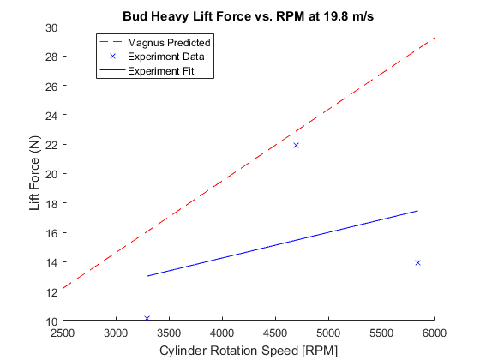
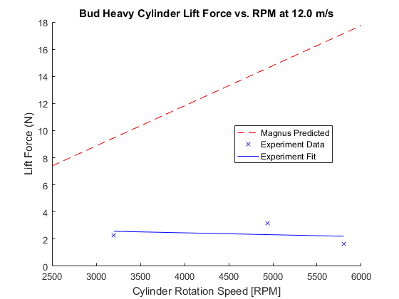

Quaker - r = 128.27/2000; % radius in [m]
rQuaker = 128.27/2000;
LQuaker = 0.2286; % length of quaker oats cylinder in meters
forceQuaker = [3.72,3.14,4.35;...
6,4.97,5.26;...
8.42,7.25,7.67;...
10.6,15.5,10.43];
RPMQuaker = [3720,4560,5560;...
3660,4470,5630;...
3675,4050,5500;...
3000,3160,5200]; % convert from [rpm] to [rps]
% expected relationship
RPMMagnusQuaker = (2500:100:6000); % [rpm]
% FL = 4*pi^2*r^2*rho*v*omega*L
FLQuaker4 = 4*pi^2*rQuaker^2*airrho*speed4.*RPMMagnusQuaker/60*LQuaker;
FLQuaker3 = 4*pi^2*rQuaker^2*airrho*speed3.*RPMMagnusQuaker/60*LQuaker;
FLQuaker2 = 4*pi^2*rQuaker^2*airrho*speed2.*RPMMagnusQuaker/60*LQuaker;
FLQuaker1 = 4*pi^2*rQuaker^2*airrho*speed1.*RPMMagnusQuaker/60*LQuaker;
% polyfitting data to line
% speed4
quakerFit4 = polyfit(RPMQuaker(4,:),forceQuaker(4,:),1);
quakerFit4x = 3000:(5200-3000)/1000:5200;
quakerFit4y = quakerFit4x*quakerFit4(1) + quakerFit4(2);
% speed3
quakerFit3 = polyfit(RPMQuaker(3,:),forceQuaker(3,:),1);
quakerFit3x = 3675:(5500-3675)/1000:5500;
quakerFit3y = quakerFit3x*quakerFit3(1) + quakerFit3(2);
% speed2
quakerFit2 = polyfit(RPMQuaker(2,:),forceQuaker(2,:),1);
quakerFit2x = 3660:(5630-3660)/1000:5630;
quakerFit2y = quakerFit2x*quakerFit2(1) + quakerFit2(2);
% speed1
quakerFit1 = polyfit(RPMQuaker(1,:),forceQuaker(1,:),1);
quakerFit1x = 3720:(5560-3720)/1000:5560;
quakerFit1y = quakerFit1x*quakerFit1(1) + quakerFit1(2);
% speed4 plots
figure;
hold on;
plot(RPMMagnusQuaker,FLQuaker4,'r--');
plot(RPMQuaker(4,:),forceQuaker(4,:),'bx',quakerFit4x,quakerFit4y,'b');
xlabel('Cylinder Rotation Speed [RPM]');
ylabel('Lift Force (N)');
title('Quaker Oats Cylinder Lift Force vs. RPM at 24.0 m/s');
l = legend('Magnus Predicted','Experiment Data','Experiment Fit','Location','best');
%set(l,'FontSize',12);
% speed3 plots
figure;
hold on;
plot(RPMMagnusQuaker,FLQuaker3,'r--');
plot(RPMQuaker(3,:),forceQuaker(3,:),'bx',quakerFit3x,quakerFit3y,'b');
xlabel('Cylinder Rotation Speed [RPM]');
ylabel('Lift Force (N)');
title('Quaker Oats Cylinder Lift Force vs. RPM at 19.8 m/s');
l = legend('Magnus Predicted','Experiment Data','Experiment Fit','Location','best');
%set(l,'FontSize',12);
% speed2 plots
figure;
hold on;
plot(RPMMagnusQuaker,FLQuaker2,'r--');
plot(RPMQuaker(2,:),forceQuaker(2,:),'bx',quakerFit2x,quakerFit2y,'b');
xlabel('Cylinder Rotation Speed [RPM]');
ylabel('Lift Force (N)');
title('Quaker Oats Cylinder Lift Force vs. RPM at 16.4 m/s');
l = legend('Magnus Predicted','Experiment Data','Experiment Fit','Location','best');
%set(l,'FontSize',12);
% speed1 plots
figure;
hold on;
plot(RPMMagnusQuaker,FLQuaker1,'r--');
plot(RPMQuaker(1,:),forceQuaker(1,:),'bx',quakerFit1x,quakerFit1y,'b');
xlabel('Cylinder Rotation Speed [RPM]');
ylabel('Lift Force (N)');
title('Quaker Oats Cylinder Lift Force vs. RPM at 12.0 m/s');
l = legend('Magnus Predicted','Experiment Data','Experiment Fit','Location','best');
%set(l,'FontSize',12);
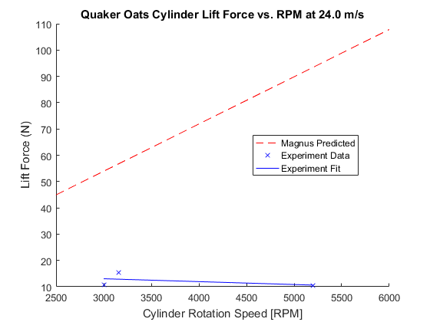
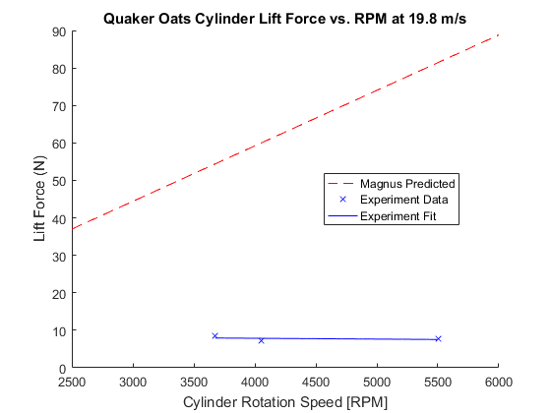
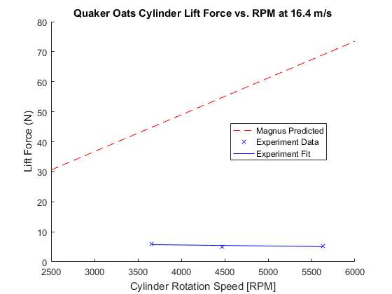
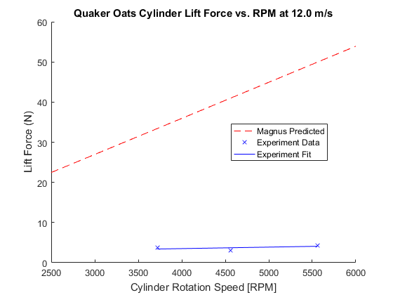

comparison to theory completed, looking for patterns within the collected
data plot of just the experimental data quaker oats cylinder
figure;
hold on;
plot(RPMQuaker(4,:),forceQuaker(4,:),'--*');
plot(RPMQuaker(3,:),forceQuaker(3,:),'--x');
plot(RPMQuaker(2,:),forceQuaker(2,:),'--d');
plot(RPMQuaker(1,:),forceQuaker(1,:),'--s');
grid on;
xlabel('Rotation Speed (RPM)');
ylabel('Life Force (N)');
title({'Measured Lift Force of Quaker Oats Cylinder vs. RPM','at Constant Wind Speeds'});
l = legend('Location','best','24.0 m/s','19.8 m/s','16.4 m/s','12.0 m/s');
%set(l,'FontSize',12);
% Bud Heavy cylinder
figure;
hold on;
plot(RPMBud(4,:),forceBud(4,:),'--*');
plot(RPMBud(3,:),forceBud(3,:),'--x');
plot(RPMBud(1,:),forceBud(1,:),'--s');
grid on;
xlabel('Rotation Speed (RPM)','FontSize',12);
ylabel('Life Force (N)','FontSize',12);
title({'Measured Lift Force of Bud Heavy Cylinder vs. RPM','at Constant Wind Speeds'});
l = legend('Location','northeast','24.0 m/s','19.8 m/s','12.0 m/s');
%set(l,'FontSize',12);
text(3150,24,'16.4 m/s wind speed has no data','FontSize',12);
% Stella cylinder
figure;
hold on;
plot(RPMStella(4,:),forceStella(4,:),'--*');
plot(RPMStella(3,:),forceStella(3,:),'--x');
plot(RPMStella(2,:),forceStella(2,:),'--d');
plot(RPMStella(1,:),forceStella(1,:),'--s');
grid on;
xlabel('Rotation Speed (RPM)');
ylabel('Life Force (N)');
title({'Measured Lift Force of Stella Cylinder vs. RPM','at Constant Wind Speeds'});
l = legend('Location','best','24.0 m/s','19.8 m/s','16.4 m/s','12.0 m/s');
%set(l,'FontSize',12);
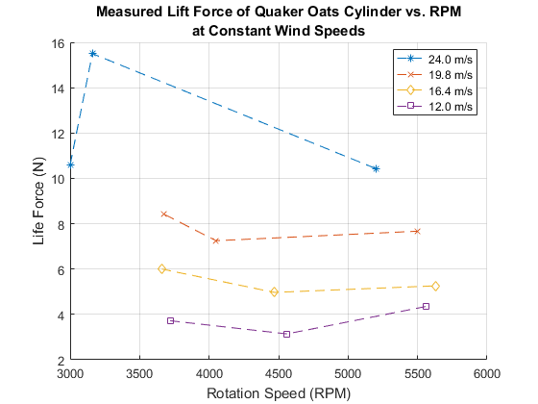
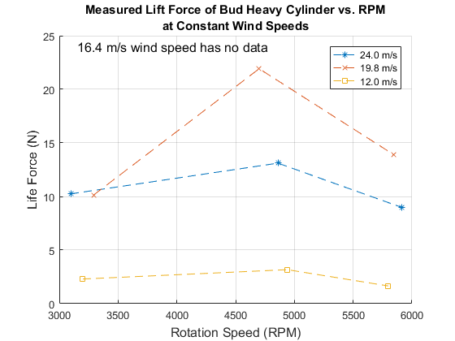
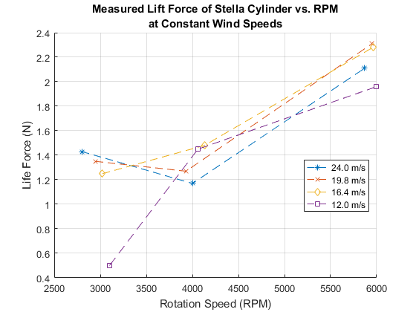

2. Effect of changing wind speed on lift force

Calculating Reynolds number for 3 cylinders and all 4 speeds
speeds1to4 = [speed1,speed2,speed3,speed4];
speeds1to5stella = [speed1,speed2,speed3,speed4,29.420];
nu = 15.11e-6; % (m^2/s) kinematic viscosity of air at room temperature
ReStella = speeds1to5stella.*(rStella*2)/nu;
ReBud = speeds1to4.*(rBud*2)/nu;
ReQuaker = speeds1to4.*(rQuaker*2)/nu;
strReStella = sprintf('Re = %1.3d \n',ReStella);
strReBud = sprintf('Re = %1.3d \n',ReBud);
strReQuaker = sprintf('Re = %1.3d \n',ReQuaker);
disp('Stella Reynolds Number for velocities in increasing magnitude (12.0,16.4,19.8,24.0) m/s')
disp(strReStella)
disp('Bud Heavy Reynolds Number for velocities in increasing magnitude (12.0,19.8,24.0) m/s')
disp(strReBud)
disp('Quaker Reynolds Number for velocities in increasing magnitude (12.0,16.4,19.8,24.0) m/s')
disp(strReQuaker)
Stella Reynolds Number for velocities in increasing magnitude (12.0,16.4,19.8,24.0) m/s
Re = 4.603e+04
Re = 6.273e+04
Re = 7.583e+04
Re = 9.206e+04
Re = 1.128e+05
Bud Heavy Reynolds Number for velocities in increasing magnitude (12.0,19.8,24.0) m/s
Re = 6.662e+04
Re = 9.079e+04
Re = 1.098e+05
Re = 1.332e+05
Quaker Reynolds Number for velocities in increasing magnitude (12.0,16.4,19.8,24.0) m/s
Re = 1.020e+05
Re = 1.389e+05
Re = 1.680e+05
Re = 2.039e+05

Plotting all the data
Experiment was conducted to have approximately the same RPM. Assuming the difference in lift force from <300 RPM difference is negligible for the purpose of seeking a pattern.
speeds = [speed4,speed3,speed2,speed1];
% Stella Cylinder
figure;
hold on;
plot(speeds,forceStella(:,3),'--*');
plot(speeds,forceStella(:,2),'-.x');
plot(speeds,forceStella(:,1),'k:d');
xlim([10 26]);
xlabel('Wind Speeds (m/s)','FontSize',12);
ylabel('Lift Force (N)','FontSize',12);
title({'Effect of Wind Speed on Stella Cylinder Lift Force','Assuming Constant RPM'});
l = legend('Location','southwest','~3000 RPM','~4000 RPM','~6000 RPM');
%set(l,'FontSize',12);
% Bud Cylinder
figure;
hold on;
plot(speeds([1,3,4]),forceBud([1,3,4],3),'--*');
plot(speeds([1,3,4]),forceBud([1,3,4],2),'-.x');
plot(speeds([1,3,4]),forceBud([1,3,4],1),'k:d');
xlim([10 26]);
xlabel('Wind Speeds (m/s)','FontSize',12);
ylabel('Lift Force (N)','FontSize',12);
title({'Effect of Wind Speed on Bud Cylinder Lift Force','Assuming Constant RPM'});
l = legend('Location','best','~3000 RPM','~5000 RPM','~6000 RPM');
%set(l,'FontSize',12);
% Oats Cylinder
figure;
hold on;
plot(speeds,forceQuaker(:,3),'--*');
plot(speeds,forceQuaker(:,2),'-.x');
plot(speeds,forceQuaker(:,1),'k:d');
xlim([10 26]);
xlabel('Wind Speeds (m/s)','FontSize',12);
ylabel('Lift Force (N)','FontSize',12);
title({'Effect of Wind Speed on Oats Cylinder Lift Force','Assuming Constant RPM'});
l = legend('Location','best','~3500 RPM','~4250 RPM','~5500 RPM');
%set(l,'FontSize',12);
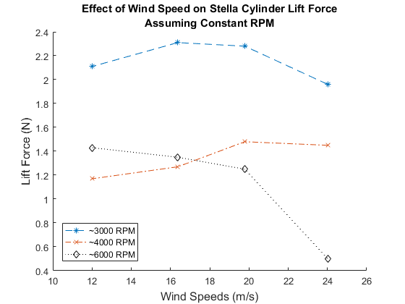
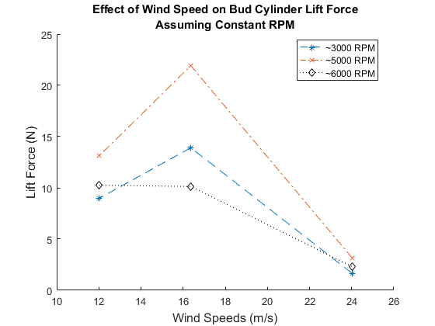
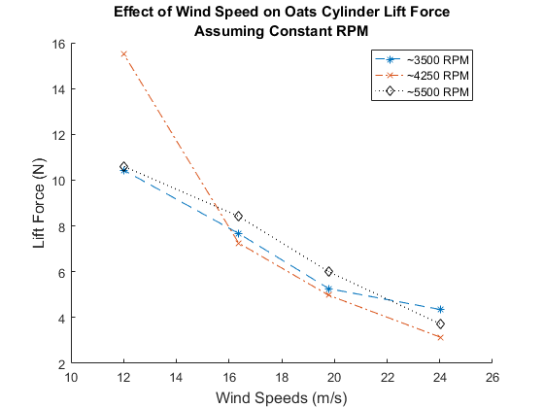

fitting the wind speed data
stellaWindRPMfit6k = polyfit(speeds',forceStella(:,1),1);
sWRfitx = speeds(4):(speeds(1) - speeds(4))/10:speeds(1);
sWRfity = sWRfitx*stellaWindRPMfit6k(1) + stellaWindRPMfit6k(2);
figure;
plot(speeds,forceStella(:,1),'*',sWRfitx,sWRfity);
xlabel('Wind Speed (m/s)','FontSize',12);
ylabel('Lift Force (N)','FontSize',12);
title('Lift Force vs. Wind Speed Stella Cylinder at ~6000 rpm');
l = legend('Location','best','Data','Best Fit');
%set(l,'FontSize',12);
budWindRPMfit6k = polyfit(speeds([1,3,4])',forceBud([1,3,4],1),1);
bWRfitx = speeds(4):(speeds(1) - speeds(4))/10:speeds(1);
bWRfity = bWRfitx*budWindRPMfit6k(1) + budWindRPMfit6k(2);
figure;
plot(speeds([1,3,4]),forceBud([1,3,4],1),'*',bWRfitx,bWRfity);
xlabel('Wind Speed (m/s)','FontSize',12);
ylabel('Lift Force (N)','FontSize',12);
title('Lift Force vs. Wind Speed Bud Cylinder ~6000 rpm');
l = legend('Location','best','Data','Best Fit');
%set(l,'FontSize',12);
quakerWindRPMfit6k = polyfit(speeds',forceQuaker(:,1),1);
qWRfitx = speeds(4):(speeds(1) - speeds(4))/10:speeds(1);
qWRfity = qWRfitx*quakerWindRPMfit6k(1) + quakerWindRPMfit6k(2);
figure;
plot(speeds,forceQuaker(:,1),'*',qWRfitx,qWRfity);
xlabel('Wind Speed (m/s)','FontSize',12);
ylabel('Lift Force (N)','FontSize',12);
title('Lift Force vs. Wind Speed Quaker Cylinder ~6000 rpm');
l = legend('Location','best','Data','Best Fit');
%set(l,'FontSize',12);
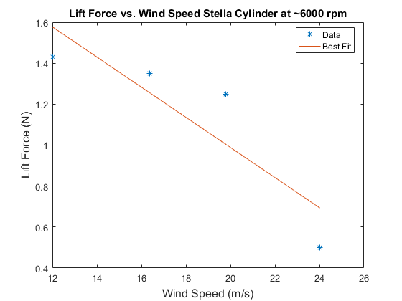
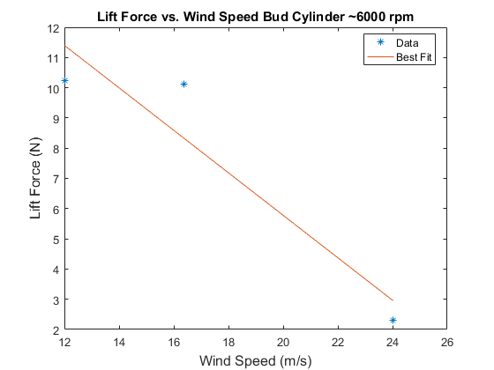
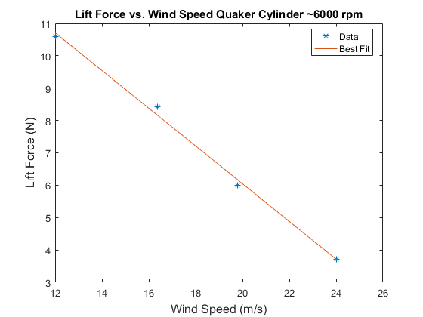

3. Effect of increasing wind speed on a fixed RPM on the lift force

Plotting and fitting
windSpeed = [11.12,16.37,20.3,23.59,26.47,29.42]; % [m/s]
liftForce = [0.67,0.61,0.5,0.4,0.36,0.47]; % [N]
windForceFit = polyfit(windSpeed,liftForce,1);
windForcex = linspace(windSpeed(1),windSpeed(end),6);
windForcey = windForcex*windForceFit(1) + windForceFit(2);

Error Analysis
confidence interval------------------------------------------- defining the degree of freedom and confidence interval
N = length(windSpeed);
dF = N - (1 + 1);
confidenceLevel = 0.975; % Matlab uses one-tail probability
% finding the t score
t = tinv(confidenceLevel,dF);
% t = 2.3060
% average value of x axis data
xMean = mean(windSpeed);
% the sum of difference of X - xbar squared
SSxx = sum((windSpeed - xMean).^2);
% finding the term of sum of difference of y axis - yfit squared
SSres = sum((liftForce - windForcey).^2);
% finding Syx
Syx = sqrt(SSres/dF);
% fit confidence interval max and min
fitCf = t*Syx*sqrt(1/N + ((windSpeed - xMean).^2)/SSxx);
minFitCf = windForcey - fitCf;
maxFitCf = windForcey + fitCf;
% measurement confidence interval max and min
measCf = t*Syx*sqrt(1 + 1/N + ((windSpeed - xMean).^2)/SSxx);
minMeaCf = windForcey - measCf;
maxMeaCf = windForcey + measCf;
% confidence interval ends--------------------------------------

Plotting everythang
figure;
plot(windSpeed,liftForce,'x',windForcex,windForcey);
hold on;
p1 = plot(windSpeed,minFitCf,'r:');
p2 = plot(windSpeed,maxFitCf,'r:');
p3 = plot(windSpeed,minMeaCf,'b--');
p4 = plot(windSpeed,maxMeaCf,'b--');
set(get(get(p2,'Annotation'),'LegendInformation'),...
'IconDisplayStyle','off');
set(get(get(p4,'Annotation'),'LegendInformation'),...
'IconDisplayStyle','off');
xlabel('Wind Speed (m/s)','FontSize',12);
ylabel('Lift Force (N)','FontSize',12);
title({'Experimental Lift Force vs. Wind Speed','for the Stella Cylinder'});
l = legend('Location','best','Experiment Data','Best fit line','Confidence of Fit','Confidence of Measurement');
%set(l,'FontSize',12);
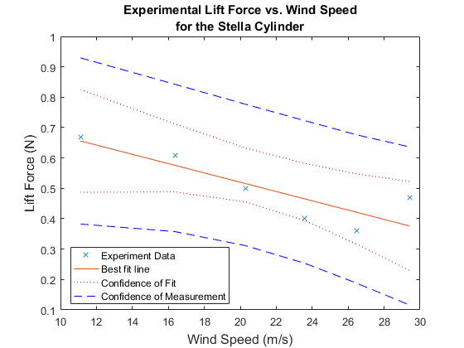

Calculateing the Coefficient of Lift
THEORETICAL
% Below calculations were done using the equation found
% in Tokumaru pdf
% Note: in the document a = radius
% CL = Lift/length*rhoair*(velocity.^2)*radius
% Coeffeicient of lift for Stella
CLthStella1 = FLStella1/(LStella*airrho*(speed1^2)*rStella);
CLthStella2 = FLStella2/(LStella*airrho*(speed2^2)*rStella);
CLthStella3 = FLStella3/(LStella*airrho*(speed3^2)*rStella);
CLthStella4 = FLStella4/(LStella*airrho*(speed4^2)*rStella);
% Coeffeicient of lift for Bud Heavy
CLthBud1 = FLBud1/(LBud*airrho*(speed1^2)*rBud);
CLthBud2 = FLBud2/(LBud*airrho*(speed2^2)*rBud);
CLthBud3 = FLBud3/(LBud*airrho*(speed3^2)*rBud);
CLthBud4 = FLBud4/(LBud*airrho*(speed4^2)*rBud);
% Coeffeicient of lift for Oats
CLthQuaker1 = FLQuaker1/(LQuaker*airrho*(speed1^2)*rQuaker);
CLthQuaker2 = FLQuaker2/(LQuaker*airrho*(speed2^2)*rQuaker);
CLthQuaker3 = FLQuaker3/(LQuaker*airrho*(speed3^2)*rQuaker);
CLthQuaker4 = FLQuaker4/(LQuaker*airrho*(speed4^2)*rQuaker);

Plot Theoretical Coefficent of Lift
figure
hold on
plot(RPMMagnusStella,CLthStella1,'-')
plot(RPMMagnusStella,CLthStella2,'-')
plot(RPMMagnusStella,CLthStella3,'-')
plot(RPMMagnusStella,CLthStella4,'-')
title('Theoretical Coefficient of Lift for Stella Cylinder')
xlabel('Velocity (m/s)')
ylabel('C_L')
legend('Location','northwest','12.0 m/s','16.4 m/s','19.8 m/s','24.0 m/s')
grid on
figure
hold on
plot(RPMMagnusBud,CLthBud1,'-')
plot(RPMMagnusBud,CLthBud2,'-')
plot(RPMMagnusBud,CLthBud3,'-')
plot(RPMMagnusBud,CLthBud4,'-')
title('Theoretical Coefficient of Lift for Bud Heavy Cylinder')
xlabel('Velocity (m/s)')
ylabel('C_L')
legend('Location','northwest','12.0 m/s','16.4 m/s','19.8 m/s','24.0 m/s')
grid on
figure
hold on
plot(RPMMagnusQuaker,CLthQuaker1,'-')
plot(RPMMagnusQuaker,CLthQuaker2,'-')
plot(RPMMagnusQuaker,CLthQuaker3,'-')
plot(RPMMagnusQuaker,CLthQuaker4,'-')
title('Theoretical Coefficient of Lift for Quaker Oat Cylinder')
xlabel('Velocity (m/s)')
ylabel('C_L')
legend('Location','northwest','12.0 m/s','16.4 m/s','19.8 m/s','24.0 m/s')
grid on
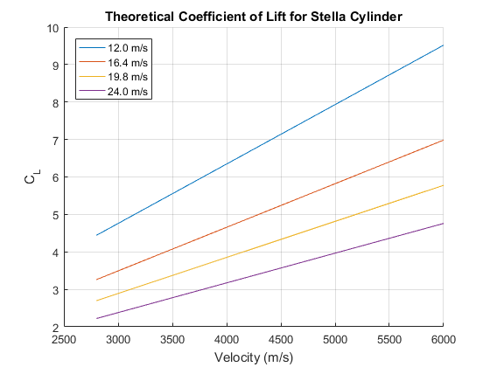
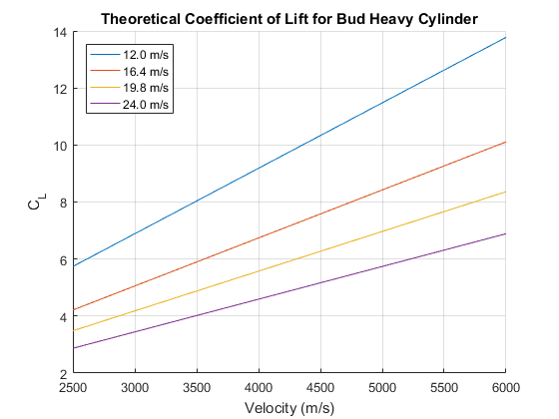
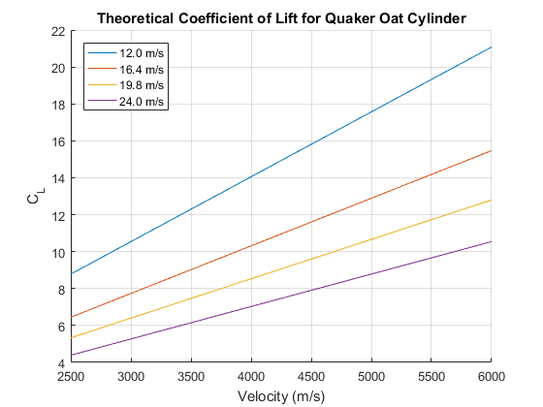

Calculateing the Coefficient of Lift
EXPERIMENTAL
% Below calculations were done using the equation found
% in Tokumaru pdf
% Note: in the document a = radius
% CL = Lift/rhoair*(velocity.^2)*radius
% All speeds in order of smallest to greatest magnitude of velocity
%speedslr = fliplr(speeds);
% Coeffeicient of lift for Stella
% Organized by trial (Constant windpeed, changing rpm)
CLexpStella1 = forceStella(1,:)./(LStella*airrho*(speed1^2)*rStella);
CLexpStella2 = forceStella(2,:)./(LStella*airrho*(speed2^2)*rStella);
CLexpStella3 = forceStella(3,:)./(LStella*airrho*(speed3^2)*rStella);
CLexpStella4 = forceStella(4,:)./(LStella*airrho*(speed4^2)*rStella);
% Constant RPM and changing wind speed for Stella error analysis
CLexpStella5 = liftForce./(LStella*airrho.*(windSpeed.^2)*rStella);
windForceFitCL = polyfit(windSpeed,CLexpStella5,1);
windForcexCL = linspace(windSpeed(1),windSpeed(end),6);
windForceyCL = windForcexCL*windForceFitCL(1) + windForceFitCL(2);
SSresCL = sum((CLexpStella5 - windForceyCL).^2);
SyxCL = sqrt(SSresCL/dF);
fitCfCL = t*SyxCL*sqrt(1/N + ((windSpeed - xMean).^2)/SSxx);
minFitCfCL = windForceyCL - fitCfCL;
maxFitCfCL = windForceyCL + fitCfCL;
measCfCL = t*SyxCL*sqrt(1 + 1/N + ((windSpeed - xMean).^2)/SSxx);
minMeaCfCL = windForceyCL - measCfCL;
maxMeaCfCL = windForceyCL + measCfCL;
% Coeffeicient of lift for Bud Heavy
% Organized by trial (Constant windpeed, changing rpm)
CLexpBud1 = forceBud(1,:)./(LBud*airrho*(speed1^2)*rBud);
CLexpBud3 = forceBud(3,:)./(LBud*airrho*(speed3^2)*rBud);
CLexpBud4 = forceBud(4,:)./(LBud*airrho*(speed4^2)*rBud);
% Coeffeicient of lift for Oats
% Organized by trial (Constant windpeed, changing rpm)
CLexpQuaker1 = forceQuaker(1,:)./(LQuaker*airrho*(speed1^2)*rQuaker);
CLexpQuaker2 = forceQuaker(2,:)./(LQuaker*airrho*(speed2^2)*rQuaker);
CLexpQuaker3 = forceQuaker(3,:)./(LQuaker*airrho*(speed3^2)*rQuaker);
CLexpQuaker4 = forceQuaker(4,:)./(LQuaker*airrho*(speed4^2)*rQuaker);

Plot for Experimental Coefficient of Lift
figure
hold on
plot(RPMStella(1,:),CLexpStella1,'--o')
plot(RPMStella(2,:),CLexpStella2,'--X')
plot(RPMStella(3,:),CLexpStella3,'--*')
plot(RPMStella(4,:),CLexpStella4,'--d')
title('Experimental Coefficient of Lift for Stella Cylinder')
xlabel('Cylinder Rotation Speed (RPM)')
ylabel('C_L')
legend('Location','northwest','12.0 m/s','16.4 m/s','19.8 m/s','24.0 m/s')
grid on
figure
hold on
plot(RPMBud(1,:),CLexpBud1,'--o')
plot(RPMBud(3,:),CLexpBud3,'--X')
plot(RPMBud(4,:),CLexpBud4,'--*')
title('Experimental Coefficient of Lift for Bud Heavy Cylinder')
xlabel('Cylinder Rotation Speed (RPM)')
ylabel('C_L')
legend('Location','northwest','12.0 m/s','19.8 m/s','24.0 m/s')
grid on
figure
hold on
plot(RPMQuaker(1,:),CLexpQuaker1,'--o')
plot(RPMQuaker(2,:),CLexpQuaker2,'--X')
plot(RPMQuaker(3,:),CLexpQuaker3,'--*')
plot(RPMQuaker(4,:),CLexpQuaker4,'--d')
title('Experimental Coefficient of Lift for Quaker Oat Cylinder')
xlabel('Cylinder Rotation Speed (RPM)')
ylabel('C_L')
legend('Location','northwest','12.0 m/s','16.4 m/s','19.8 m/s','24.0 m/s')
grid on
figure;
plot(windSpeed,CLexpStella5,'x',windForcexCL,windForceyCL);
hold on;
p1 = plot(windSpeed,minFitCfCL,'r:');
p2 = plot(windSpeed,maxFitCfCL,'r:');
p3 = plot(windSpeed,minMeaCfCL,'b--');
p4 = plot(windSpeed,maxMeaCfCL,'b--');
set(get(get(p2,'Annotation'),'LegendInformation'),...
'IconDisplayStyle','off');
set(get(get(p4,'Annotation'),'LegendInformation'),...
'IconDisplayStyle','off');
xlabel('Wind Speed (m/s)','FontSize',12);
ylabel('C_L','FontSize',12);
title({'Experimental Coefficient of Lift vs. Wind Speed','for the Stella Cylinder'});
l = legend('Location','best','Experiment Data','Best fit line','Confidence of Fit','Confidence of Measurement');
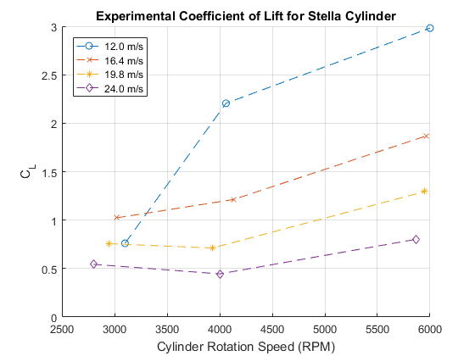
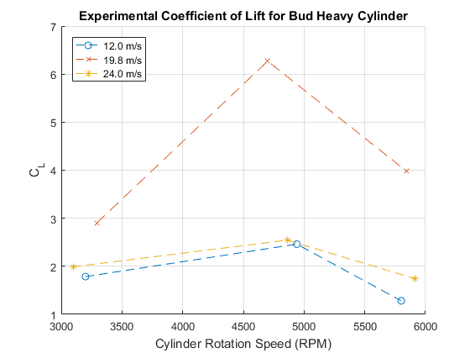
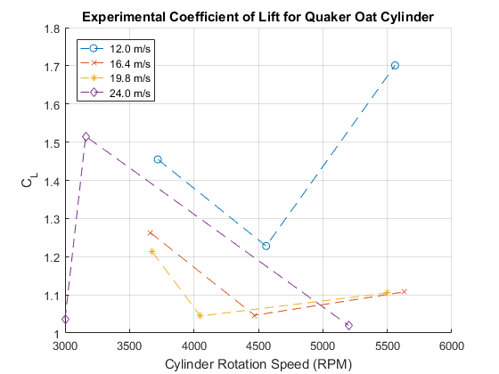
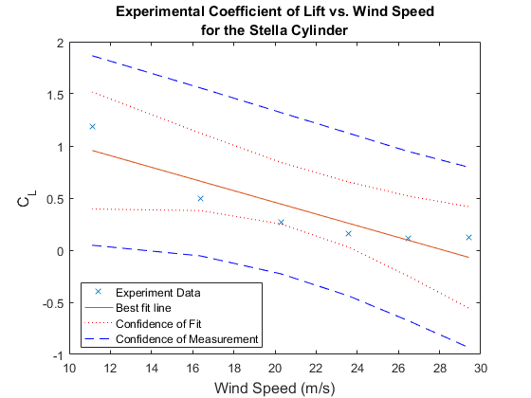

Experimental vs Theoretical CL
CLfitStella1 = polyfit(RPMStella(1,:),CLexpStella1,1);
CLfitStella2 = polyfit(RPMStella(2,:),CLexpStella2,1);
CLfitStella3 = polyfit(RPMStella(3,:),CLexpStella3,1);
CLfitStella4 = polyfit(RPMStella(4,:),CLexpStella4,1);
bfStella1 = RPMStella(1,:)*CLfitStella1(1) + CLfitStella1(2);
bfStella2 = RPMStella(2,:)*CLfitStella2(1) + CLfitStella2(2);
bfStella3 = RPMStella(3,:)*CLfitStella3(1) + CLfitStella3(2);
bfStella4 = RPMStella(4,:)*CLfitStella4(1) + CLfitStella4(2);
figure
hold on
plot(RPMStella(1,:),CLexpStella1,'bo')
plot(RPMStella(2,:),CLexpStella2,'rx')
plot(RPMStella(3,:),CLexpStella3,'kd')
plot(RPMStella(4,:),CLexpStella4,'c*')
bf1 = plot(RPMStella(1,:),bfStella1,'b-');
bf2 = plot(RPMStella(2,:),bfStella2,'r-');
bf3 = plot(RPMStella(3,:),bfStella3,'k-');
bf4 = plot(RPMStella(4,:),bfStella4,'c-');
plot(RPMMagnusStella,CLthStella1,'b--')
plot(RPMMagnusStella,CLthStella2,'r--')
plot(RPMMagnusStella,CLthStella3,'k--')
plot(RPMMagnusStella,CLthStella4,'c--')
title({'Experimental vs Theoretical Coefficient of Lift','for the Stella Cylinder'})
xlabel('Cylinder Rotation Speed (RPM)')
ylabel('C_L')
text(4000,bfStella1(3),'Experimental Best Fit line \downarrow','verticalalignment','top')
text(3500,CLthStella1(end-3),'Dashed lines represent theoretical C_L \downarrow','verticalalignment','top')
legend([bf1 bf2 bf3 bf4],{'12.0 m/s','16.4 m/s','19.8 m/s','24.0 m/s'},'Location','northwest')
grid on
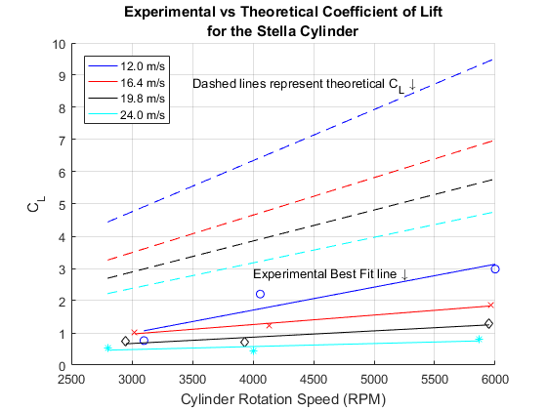

Vortex Shedding
% Below approximation generally holds true for range of Reynolds numbers in
% 250 < Re < 2x10^5
% Strouhal Number
StStella = 0.198*(1 - 19.7./ReStella);
StBud = 0.198*(1 - 19.7./ReBud);
StQuaker = 0.198*(1 - 19.7./ReQuaker);
% f = St*v_wind/diameter
% Vortex frequency
fvStella = StStella.*speeds1to5stella/(rStella*2);
fvBud = StBud.*speeds1to4/(rBud*2);
fvQuaker = StQuaker.*speeds1to4/(rQuaker*2);

Misc Info
MStoMPH = 2.23694; % m/s to mph
mph1 = speed1*MStoMPH; % slowest test speed m/s to mph
mph4 = speed4*MStoMPH; % fastest for most tests m/s to mph
mphMAX = windSpeed(end)*MStoMPH; % Max wind speed for stella on the last test
mphstr1 = sprintf('Our slowest test wind speed of %1.1f m/s = %1.1f mph',speed1,mph1);
mphstr2 = sprintf('Our "fastest" test wind speed (for our primary tests of 3 cylinders) of %1.1f m/s = %1.1f mph',speed4,mph4);
mphstr3 = sprintf('Our MAX test wind speed on Stella was %1.1f m/s = %1.1f mph',windSpeed(end),mphMAX);
disp(mphstr1)
disp(mphstr2)
disp(mphstr3)
Our slowest test wind speed of 12.0 m/s = 26.9 mph
Our "fastest" test wind speed (for our primary tests of 3 cylinders) of 24.0 m/s = 53.7 mph
Our MAX test wind speed on Stella was 29.4 m/s = 65.8 mph
omega0_Stella1 = RPMStella(1,:)/60*2*pi*rStella/speed1;
omega0_Stella2 = RPMStella(2,:)/60*2*pi*rStella/speed2;
omega0_Stella3 = RPMStella(3,:)/60*2*pi*rStella/speed3;
omega0_Stella4 = RPMStella(4,:)/60*2*pi*rStella/speed4;
omega0_Quaker1 = RPMQuaker(1,:)/60*2*pi*rQuaker/speed1;
omega0_Quaker2 = RPMQuaker(2,:)/60*2*pi*rQuaker/speed2;
omega0_Quaker3 = RPMQuaker(3,:)/60*2*pi*rQuaker/speed3;
omega0_Quaker4 = RPMQuaker(4,:)/60*2*pi*rQuaker/speed4;
omega0 = [omega0_Stella1(1),omega0_Stella2(1:2),omega0_Stella3,omega0_Stella4,...
omega0_Quaker1(1:2),omega0_Quaker2,omega0_Quaker3,omega0_Quaker4];
CLexp = [CLexpStella1(1),CLexpStella2(1:2),CLexpStella3,CLexpStella4,...
CLexpQuaker1(1:2),CLexpQuaker2,CLexpQuaker3,CLexpQuaker4];
[omegafit,S] = polyfit(omega0.^0.3,CLexp,1);
% R^2 values for the fit
disp(['R^2 Value of the Fit: ',num2str(1 - S.normr^2 / norm(CLexp-mean(CLexp))^2)]);
omega0Fit = linspace(0,3.5,100);
% CLFit = omega0Fit.^(0.08);
CLFit = (omega0Fit-0.3).^0.3;
figure;
hold on;
pp4 = plot(omega0_Stella1([2,3]),CLexpStella1([2,3]),'kX');
plot(omega0_Stella2(3),CLexpStella2(3),'kX',omega0_Quaker1(3),CLexpQuaker1(3),'kX');
plot(omega0_Stella1(1),CLexpStella1(1),'b*');
pp1 = plot(omega0_Stella2([1,2]),CLexpStella2([1,2]),'b*');
plot(omega0_Stella3,CLexpStella3,'b*');
plot(omega0_Stella4,CLexpStella4,'b*');
pp2 = plot(omega0_Quaker1([1,2]),CLexpQuaker1([1,2]),'r*');
plot(omega0_Quaker2,CLexpQuaker2,'r*');
plot(omega0_Quaker3,CLexpQuaker3,'r*');
plot(omega0_Quaker4,CLexpQuaker4,'r*');
pp3 = plot(omega0Fit(9:end),CLFit(9:end),'--');
box;
xlabel('\Omega_0 (normalized speed)','FontSize',12);
ylabel('C_L','FontSize',12);
legend([pp1 pp2 pp3 pp4],...
{'Stella C_L','Quaker Oats C_L','Suggested Relationship','Outlaying data not considered for the fit'},...
'Location','southeast')
R^2 Value of the Fit: 0.39125
Warning: Imaginary parts of complex X and/or Y arguments ignored
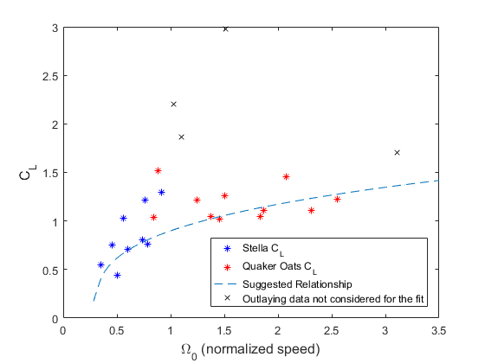
Published with MATLAB® R2016a

